COUNTY

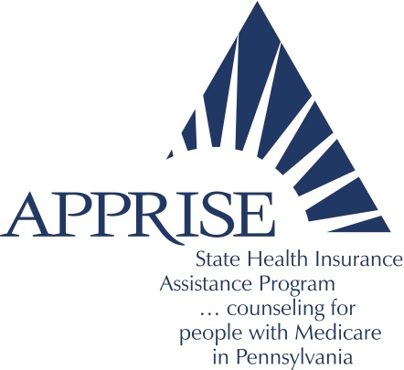

DAUPHIN

OFFICE OF AREA AGENCY ON AGING
DAUPHIN COUNTY ADMINISTRATION BUILDING
3rd FLOOR
2 SOUTH SECOND STREET
HARRISBURG, PA 17101
(717)780-6130

Are you new to Medicare? Do you have unanswered questions about Medicare?

Dauphin County APPRISE will be conducting

MEDICARE 101

Seminars will be open to the public at the following locations:

Mohler Senior Center Rutherford House Senior Center Millersburg Senior Center
(25 Hope Dr. Hershey 17033) (3300 Parkview Ln. Hbg 17111) (109 Edward Dr. Millersburg 17061)

Thursday 03/26/20 9AM Thursday 04/23/20 9AM Wednesday 04/29/20 11:30AM
Thursday 05/28/20 9AM Thursday 06/25/20 9AM
Thursday 07/23/20 9AM Thursday 08/27/20 9AM Wednesday 09/09/20 11:30AM
Thursday 09/24/20 9AM Thursday 10/22/20 9AM
Thursday 11/19/20 9AM

These seminars will go over the basics of Medicare Parts A, B, C & D; comparisons between Medicare Advantage and Medicare Supplement Plans, and programs available to help save money!

One on one appointments can be scheduled on site and may be available after the presentation for those interested in having medication comparisons done (bring your Rx list).
Questions, contact: Shannon Vallier, APPRISE Coordinator (717) 780-6130 Ext. 6147

